**Matillion Git Setup Process**

1. Create Github repository ‘Data_Ingestion_Matillion’ under ‘data-and-analytics’ organization.
2. Switch to Data Replication project in Dev environment

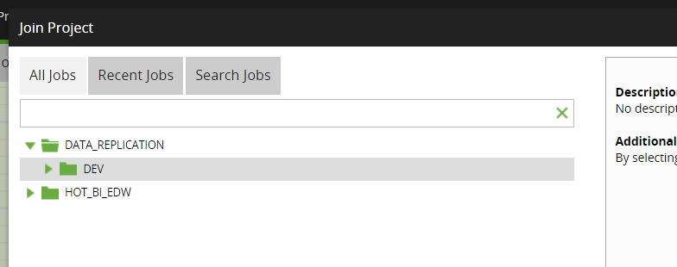

1. Select ‘Git’ option from the project drop down menu.
2. Configure the Git repo by selecting the gears button from the Git pop up window. Once git repo link is added click OK button.

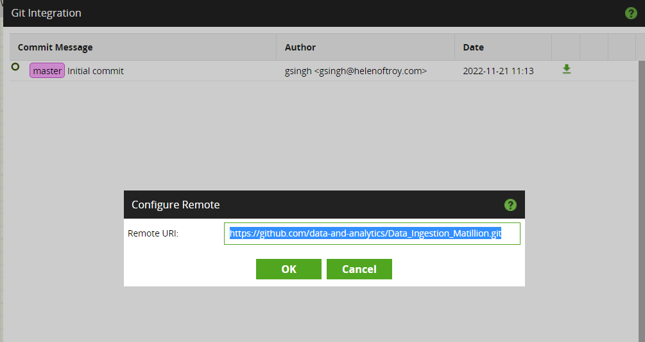

1. Click on the lock button on Git pop up window. It will ask for user name and Git token as per below screenshot. Enter the requested details and press OK button.

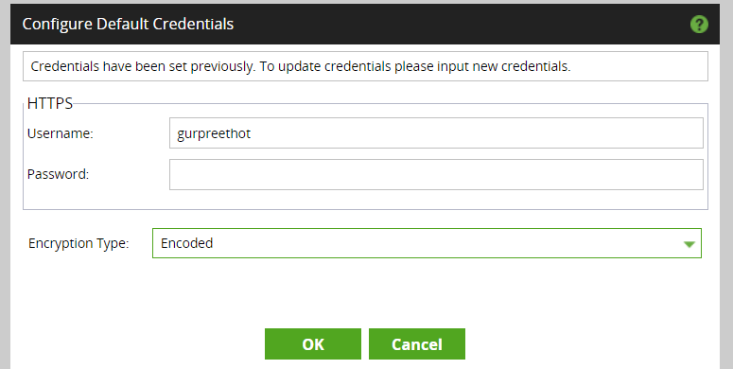

1. There are certain options which matillion provides on Git pop up window as per below screenshot.

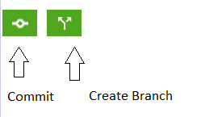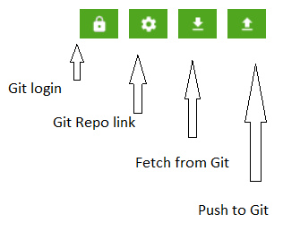

**Matillion Jobs Setup process**

1. Login to lower environment like DEV in Matillion instance from where jobs are to be migrated.
2. Right click on the Folder or the set of jobs to be exported.

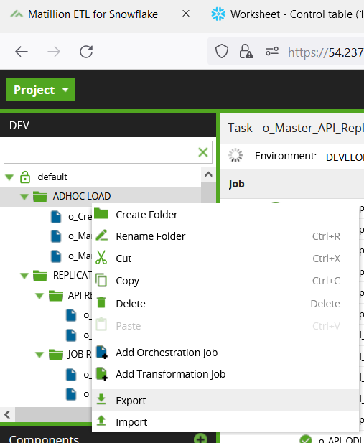

1. Select the jobs to export which will create a json file.

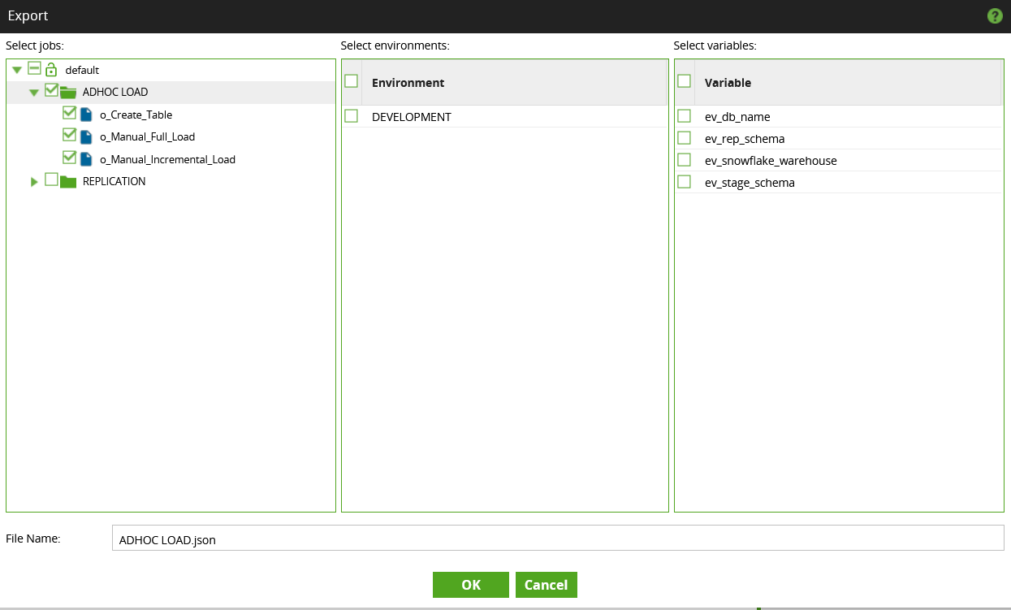

1. Switch to higher environment.

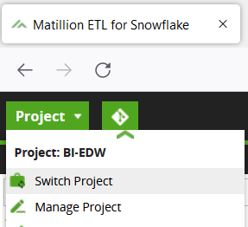

1. Right click on the *default* to import the jobs.

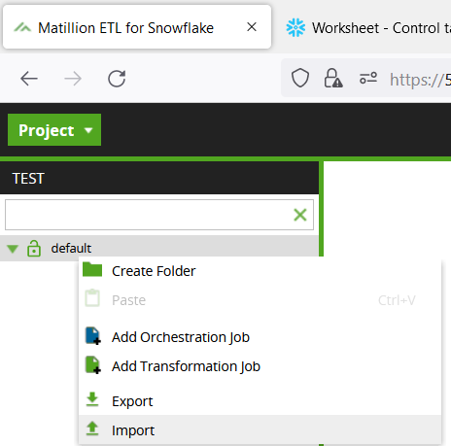

1. Select the json file which will show exported jobs to import from.

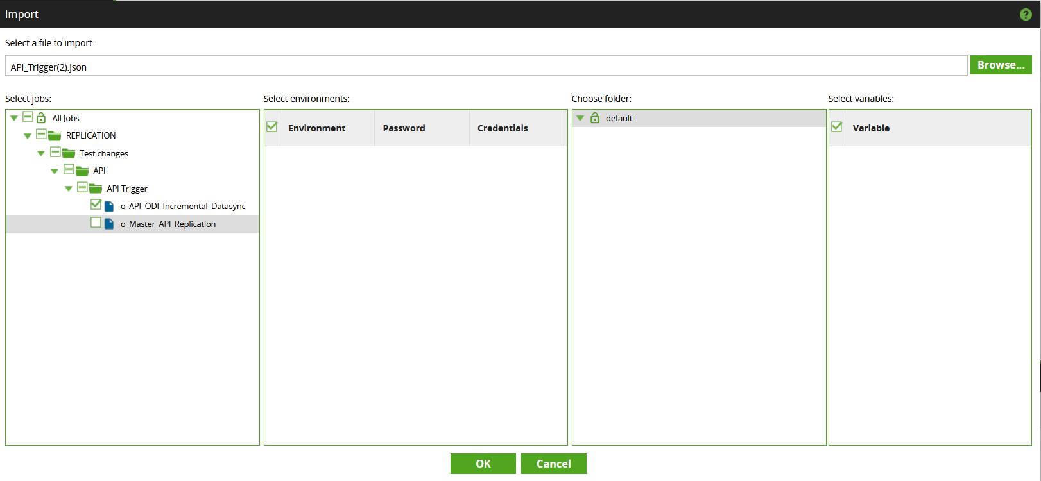

1. Make sure to create the environment variables in the higher environment if they are not present.

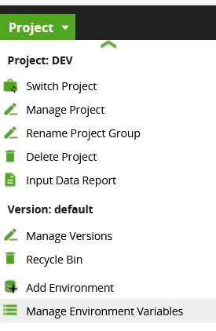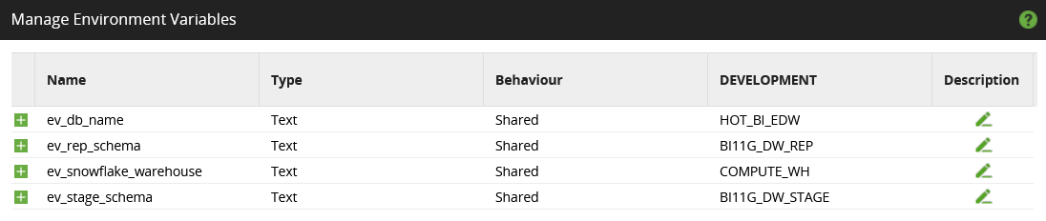

This completes the process to migrate the jobs from lower to higher environment.